How train_gnn Works: Temporal Graph Model for Combat ID
Nov 3, 2026 · Clay Stanek

1. At a glance
train_gnn learns to assign each air track a calibrated probability of being Friend, Neutral or Hostile, using both the track's own recent history and what is happening around it. It trains one model per scenario on the generator's runs, calibrates its probabilities on held-out runs, and writes predictions for the test runs that compare scores against the Bayesian Network and tree baselines.
The model has three stages, run in order for every track at every snapshot:
- Temporal encoder (GRU). Summarizes the track's last 30 seconds of evidence into a 128-number vector.
- Graph layers. Let each track refine that summary using its neighbors, the defended assets and nearby ESM fixes.
- Output heads. Turn the result into allegiance probabilities, plus two auxiliary predictions.
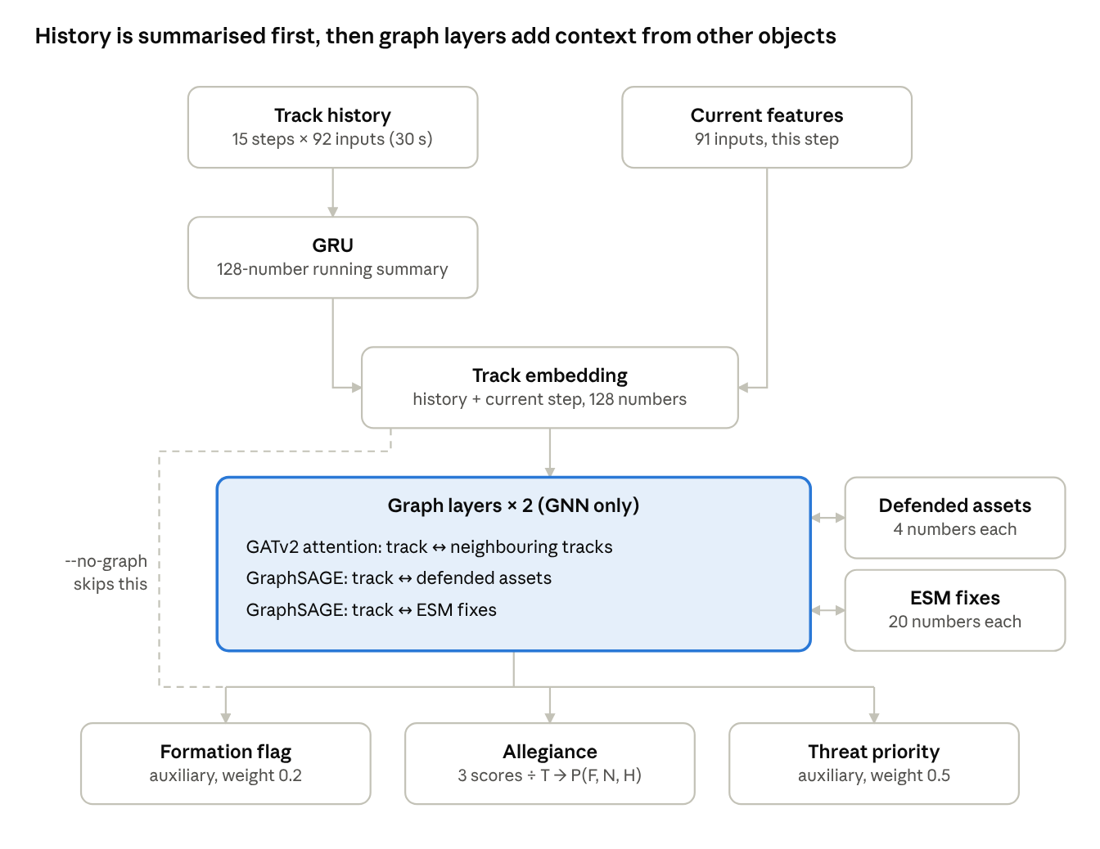
model architecture · per track, per snapshot
The shaded block is the only part the GRU-only variant leaves out; everything else, including the GRU, is shared.
Two variants are trained from the same command:
Variant | Command | Stages used | Answers
GNN | train_gnn | 1 + 2 + 3 | How well can history and relationships identify a track?
GRU only | train_gnn --no-graph | 1 + 3 | How much of that comes from history alone?
Both variants contain the GRU; the switch removes the graph layers. The difference between them isolates what relationships between objects add, which is the hypothesis this program set out to test.

2. The prediction task
Every 10 seconds of scenario time, the model classifies every track held at that moment. Each such moment is a snapshot: a picture of the whole air situation, with one node per track. A 30-minute run gives 180 snapshots.
Inputs per track. 91 numbers per 2-second step, all computed from sensor reports rather than truth:
Group | Examples | Count
Kinematics and track quality | speed, altitude, climb, turn rate, position uncertainty | 8
Radar signature | RCS median and spread, micro-Doppler features, jamming flag, which radars hold the track | 9
IFF | Mode 3/C, Mode 5 valid, Level 2 position residual, ever replied validly, in IFF coverage | 8
NCTR (JEM, LIDAR, EO/IR) | confidence, blade feature, segment lengths, report age | 11
ESM | best fix confidence, band, distance to fix, how many tracks share the fix | 5
Context | airway and corridor distance, angle from threat axis, range, closure, time-to-go and CPA to assets, descent while closing | 10
Missing-data indicators | one flag per sensor family: did it report at all? | 6
Categorical codes | top engine, EO/IR class and emitter, one-hot | 34
Distances and times are log-scaled, so 1 km and 100 km differ by about the same amount as 100 m and 10 km. Missing values become 0, and the missing-data flags tell the model that the 0 means "no report" rather than a measurement.
Outputs per track. Probabilities over Friend, Neutral and Hostile. Two auxiliary outputs help training: whether the track is an unresolved formation, and its threat priority.
Birds appear as nodes, because a real system would hold them as tracks. They take part in message passing but are excluded from the loss and the scores.

3. From runs to training examples
One training example is one snapshot, not one track: the model sees the whole scene at once, and the loss is averaged over the tracks in it. Runs are converted once into a compact cache, then sliced into snapshots on the fly.
The cache (--cache folder, one file per run, built on first use). It holds:
- a feature cube of shape tracks × time steps × 91, stored at 2-second resolution;
- a held mask recording when each track existed;
- for every snapshot, which tracks are present, their labels, the graph edges and the asset and ESM-fix node features.
The 30-second history window is cut from the cube when a snapshot is loaded, so the cache stays at about 25 MB per S0 run.
Normalization. Each of the 91 features is standardized to mean 0 and standard deviation 1, using statistics from the training runs only, and clipped to ±10. Edge attributes and ESM-fix features are standardized the same way. Test data never influences these statistics, which matters most for the S9 shift test.
Class weights. Hostile tracks outnumber friends roughly 3 to 1. The loss weights each class by the inverse of its training frequency (typically about 1.5 Friend, 1.0 Neutral, 0.5 Hostile), so the model is not rewarded for ignoring friends.
The split is by run, never by snapshot. Snapshots from the same run share aircraft and are strongly correlated; splitting them would leak test aircraft into training.
Seeds per scenario | Train | Validation | Test
20 | 1–14 | 15–17 | 18–20
10 | 1–6 | 7–8 | 9–10
Validation runs are used only to decide when to stop training and to calibrate probabilities. compare uses the same split, so every model family is scored on the same test aircraft.

4. The temporal encoder: what a GRU does
A GRU reads a track's history one step at a time and keeps a running summary, learning for itself which past evidence is worth remembering. That matters here because some of the strongest identity evidence is about what happened earlier: a friend whose transponder failed two minutes ago replied validly before it failed; a hostile switched its radar on only once it was inside 80 km.
How it works. A recurrent network keeps a hidden state h, here 128 numbers. At each time step it combines the previous state with the new input and produces an updated state. A plain recurrent network overwrites its state at every step and so forgets quickly. A gated recurrent unit (GRU) adds two learned gates, each a set of 128 values between 0 and 1 computed from the current input and the previous state:
- the update gate z decides how much of the old summary to keep versus replace;
- the reset gate r decides how much of the old summary to use when proposing the replacement.
$${\tilde{h}}_{t}=\tanh{​}\left(Wx_{t}+U\left(r_{t}⊙h_{t-1}\right)\right) \\ h_{t}=\left(1-z_{t}\right)⊙h_{t-1}+z_{t}⊙{\tilde{h}}_{t}$$
When z is near 0 for some component, that part of the summary passes through unchanged; when near 1, it is rewritten from the current evidence. The weights W and U and those of the gates are learned, so the network discovers which evidence to hold onto. A Kalman filter is a useful comparison: it also carries a state forward and blends in new measurements, but with a gain fixed by a model. The GRU learns its own blending, and what to carry.
What it sees. For each track, the last 15 steps of 2 seconds, so 30 seconds, of the 91 features, plus a 92nd input that says whether the track was held at that step. Steps before the track existed are zeros with that flag off, so a new track is recognizably new.
What comes out. The GRU's final state is joined with a separate encoding of the current step's features and passed through one more layer, giving the track's 128-number embedding. In the GRU-only variant this embedding goes straight to the output heads; in the GNN it is the starting point for message passing.

5. The graph layers: message passing
A graph layer lets every node update its embedding using its neighbors' embeddings. Stacking two layers lets information travel two hops, so a track can learn from a neighbor's neighbor, or from another track that claims the same ESM fix. This is how evidence about one aircraft can inform the identity of another, which a per-track Bayesian Network cannot do.

Nodes and edges
Each snapshot is a heterogeneous graph: three kinds of node joined by three kinds of edge, each with its own learned weights.
Node type | Starts as
Track | the 128-number embedding from the GRU
Defended asset | value, defended radius and position (4 numbers), mapped to 128
ESM fix | fix uncertainty, confidence, band, number of sites, altitude and emitter one-hot (20 numbers), mapped to 128

Edge type | Connects | Rule | Layer | Edge attributes used
track ↔ track | neighboring tracks | within 25 km (2 km if either is Tier 1), up to 8 nearest | GATv2 | relative position and velocity, distance, heading difference, speed ratio, 60 s co-movement correlation
asset ↔ track | each track and each asset | asset within 300 km | GraphSAGE | none in v0.3
ESM fix ↔ track | each fix and its candidate tracks | fix from the last 4 s, track within 3σ of it | GraphSAGE | none in v0.3
Asset and ESM edges run in both directions. In the first layer an ESM fix learns which tracks claim it; in the second, each track hears back from the fix. This gives a learned, soft version of measurement-to-track attribution: a fix shared by three tracks speaks less clearly about any one of them.

GATv2: attention over neighboring tracks
For track i, GATv2 scores every neighbor j from both embeddings and the edge attributes, turns the scores into weights that sum to 1, and takes the weighted sum of the neighbors' transformed embeddings:
$$s_{ij}=a^{⊤} \operatorname{LeakyReLU}{​}\left(W_{1}h_{i}+W_{2}h_{j}+W_{e}e_{ij}\right)$$
$$α_{ij}=\frac{\exp{​}\left(s_{ij}\right)}{\sum_{k}{\exp{​}}\left(s_{ik}\right)}$$
$$m_{i}=\sum_{j}{α_{ij}} W_{2}h_{j}$$The weights α are learned, so the model can attend to a co-moving wingman 1.5 km away and largely ignore an airliner crossing 20 km off. Four attention heads run in parallel, each with 32 output dimensions, and are concatenated back to 128; each head can learn a different notion of relevance. A self-loop is added so a track with no neighbors still updates from its own embedding. The "v2" refers to applying the nonlinearity before the scoring vector a, which lets the ranking of neighbors depend on the receiving track.
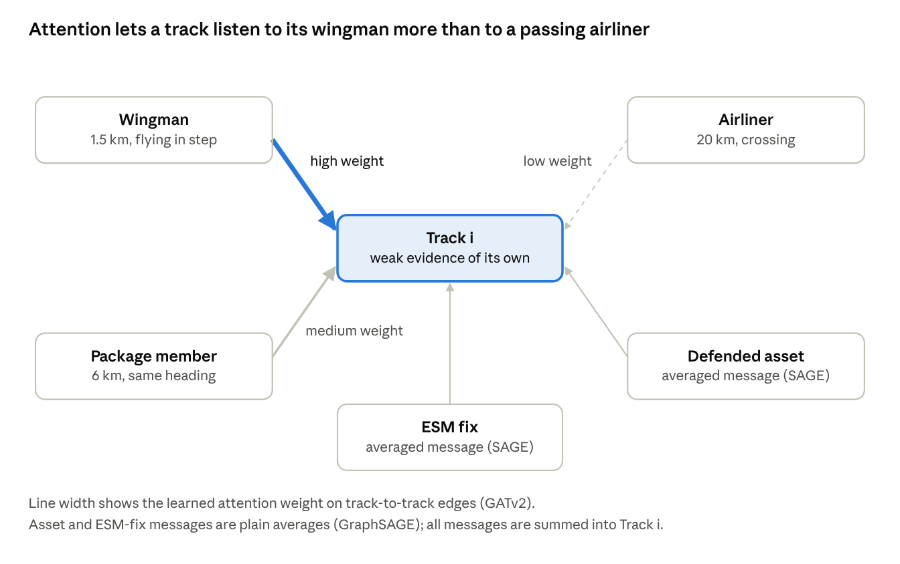
one message-passing step for a single track (illustrative)
An illustrative step: the weights are learned from data, not set by hand, and differ for every track and snapshot.

GraphSAGE: averaging for assets and ESM fixes
For asset and ESM edges, each node takes the plain mean of its neighbours' embeddings, applies a learned linear map, and adds a learned linear map of its own embedding. There is no attention: these neighbourhoods are small, and their meaning does not need ranking.

Combining the messages
A track's messages from the three edge types are summed. The update is then residual:
$$h_{i} ← \operatorname{LayerNorm}{​}\left(h_{i}+\operatorname{Dropout}{​}\left(\operatorname{GELU}\left(m_{i}\right)\right)\right)$$Because each layer adds a correction to h rather than replacing it, the graph can refine the GRU's evidence but not discard it, and an isolated track keeps essentially its GRU summary. LayerNorm keeps the embeddings at a stable scale from layer to layer.

6. Outputs and the training loss
Three small heads read each track's final embedding. Only the allegiance head is scored; the other two are auxiliary tasks that encourage the shared embedding to capture structure useful for identification.
Head | Architecture | Target | Loss | Weight
Allegiance | 128 → 128 → 3 | Friend, Neutral, Hostile | class-weighted cross-entropy, birds excluded | 1.0
Unresolved formation | 128 → 2 | is this radar track several aircraft merged? | cross-entropy | 0.2
Threat priority | 128 → 1 | the generator's threat score (0 for non-hostiles) | mean squared error | 0.5
$$L={CE}_{w}\left(allegiance\right)+0.2 CE\left(formation\right)+0.5 MSE\left(threat\right)$$The threat head is trained but not yet evaluated, and does not feed the ranking that operators would see. It is a placeholder for the threat-prioritization half of the problem.
The GNN has about 0.48 million learned parameters, of which 0.33 million (69%) are in the two graph layers. The GRU-only variant has about 0.15 million.

7. Training, early stopping and calibration
The model is trained by gradient descent on batches of 16 snapshots, the epoch with the best validation log loss is kept, and its probabilities are then rescaled so that a stated 90% is right about 90% of the time.
Setting | Value | Why
Optimizer | AdamW, learning rate 1e-3, weight decay 1e-4 | standard, robust default
Learning-rate schedule | cosine decay over the epoch budget | large steps early, fine steps late
Batch | 16 snapshots (all their tracks) | about 1,500 tracks per step in S0
Maximum epochs | 30 | one epoch = every training snapshot once
Dropout | 0.15 | regularization, including on attention weights
Gradient clipping | norm 5 | guards against occasional large steps
Early stopping | stop after 6 epochs without improvement in validation log loss | avoids overfitting the 14 training runs
Model kept | the epoch with the lowest validation log loss | not the last epoch
In the v0.2 runs, training stopped between epochs 8 and 23 and took 3 to 8 minutes per scenario on the RTX 5090. Validation loss was noisy from epoch to epoch because there are only three validation runs, which is why the best epoch is kept rather than the last.
Calibration by temperature scaling. Neural networks are usually overconfident: a raw output of 0.99 may be right much less than 99% of the time. After training, the model's raw scores (logits) on the validation runs are divided by a single number T, chosen to minimize validation log loss, and the same T is applied to the test predictions.
$$p=softmax\left(\frac{z}{T}\right)$$T > 1 softens overconfident probabilities. In v0.2, T fell between 1.5 and 2.0 for every scenario, so the raw model was clearly overconfident and calibration mattered. Because T rescales all logits equally, it changes how confident the model is, never which class it picks: accuracy is unchanged, log loss and calibration error improve.

8. Reading the comparison
The two variants are identical in data, split, training settings and calibration; the only difference is whether the two graph layers run. So the gap between them is the value of relationships, measured on the same aircraft.
Outcome | Interpretation
GNN better than GRU, both better than BN | Relationships between objects add information; the program's hypothesis holds
GNN ≈ GRU, both better than BN | The gain comes from learning on track history, not the graph; a temporal model alone would do
GRU better than GNN | The graph adds noise, for example edges linking airliners to strike packages
BN ≈ GRU ≈ GNN | The scenario is too easy, or its information is all per-track (expected for S1)
Two scenarios act as controls. In S1, where every relational mechanism is switched off, the GNN should not beat the GRU; if it does, information is leaking through the graph. The guardrail columns in compare, airliners called hostile and friends called hostile, should be no worse for the GNN than for the GRU, since spreading suspicion to bystanders is the classic graph-model failure.
compare reports 95% intervals by resampling whole aircraft, and a verdict against BN-oracle. Treat "no clear difference" as a tie, however the point estimates look.

Shift mode
With --test-runs, the model trains and calibrates on one scenario's runs and is tested on another's, for example trained on S0 and tested on S9 with noisier radars, a missing radar, worse ESM and a different force mix. normalization statistics, class weights and temperature all come from the training scenario, as they would in a fielded system meeting conditions it was not built for. This is the closest the testbed comes to the live-environment underperformance that motivates the work.

9. Command-line options and output files
python -m cidgen.models.train_gnn --runs "runs/S0_*" "runs/S7_*" --out results --cache <cache folder>
python -m cidgen.models.train_gnn --runs "runs/S0_*" --test-runs "runs/S9_*" --out results --cache <cache folder> --no-graph
Option | Default | Effect
--runs | required | run folders or quoted glob patterns; one model is trained per scenario found
--test-runs | none | shift mode: train and validate on --runs, test on these
--no-graph | off | GRU-only variant: skip the graph layers
--out | results | where predictions, weights and logs go
--cache | cache | where the per-run cache lives; delete it after regenerating runs
--window | 15 | history length in 2 s steps (15 = 30 s)
--hidden | 128 | embedding size
--layers | 2 | graph layers, so hops of message passing
--epochs, --patience | 30, 6 | epoch budget and early-stopping patience
--batch, --lr | 16, 1e-3 | snapshots per step, learning rate
--val-frac, --test-frac | 0.15, 0.15 | share of seeds held out; keep the defaults so compare uses the same split
--device, --seed, --workers | cuda, 0, 0 | GPU, random seed, data-loader processes (0 is safest on Windows)

File in --out | Contents
pred_gnn_<scenario>.csv, pred_gru_<scenario>.csv | calibrated test probabilities per track and snapshot; read by compare
gnn_<scenario>.pt, gru_<scenario>.pt | weights, normalization statistics, temperature and settings; load with torch.load(path, weights_only=False)
train_gnn.log, train_gru.log | per-epoch losses; appended, so earlier runs remain above
summary_gnn.json, summary_gru.json | temperature, test accuracy and test size per scenario
In shift mode the scenario part of each name is <train>__on__<test>, for example pred_gnn_S0_baseline__on__S9_sensor_shift.csv.

10. Design choices and known limitations
These are deliberate simplifications for a first model; each is a candidate for the next iteration.
Area | Current choice | Consequence | Possible next step
Memory | GRU sees 30 s; longer history only through accumulated features such as "ever replied validly" | Evidence older than 30 s survives only if a feature carries it | Longer window, or carry the GRU state across snapshots
Output smoothing | each snapshot is classified independently | the label can flicker between snapshots | recursive fusion of successive outputs
Graph construction | fixed rule: distance gate, 8 nearest neighbors | wrong edges, such as an airliner near a package, are the main risk; attention can down-weight them but not remove them | learned or behavior-based gating
Asset and ESM edges | GraphSAGE ignores their attributes; nearest-asset geometry reaches the model through per-track features | relations to the second-nearest asset are only partly used | edge-aware layers on these edges too
Class weighting | inverse-frequency weights in the loss | probabilities lean toward the rarer classes; temperature scaling fixes confidence but not this lean | rebalance by prior correction after training
Validation size | 3 runs per scenario | early stopping and temperature are somewhat noisy | more seeds, or cross-validation over runs
Training seeds | one random initialization per model | small differences between models may be initialization luck | train 3 seeds and average before drawing conclusions
Tracking | association comes from the generator; tracks never swap or split | real track breaks and swaps are absent | add a tracker to the generator
Threat priority | trained as an auxiliary task, not evaluated | no ranking result yet | score it against the threat label with ranking metrics
The model never sees the true tier, class or allegiance as an input; it infers tier from the evidence, as the Bayesian Network does through its observable-tier routing.

